http://healthdiseasegenetics.blogspot.com/2018/05/punganur-dwarf-cattle-breed.html

Monday, May 28, 2018

Production traits - Daily milk yield (Kg): 2.29±0.06 kg, Lactation period: 272.0±8.9 days
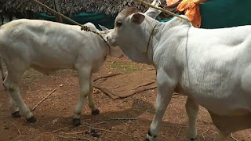
Milk production per lactation: 633.4±21.7 kg , Average milk fat: 5.00%, Average solid not fat: 7.69 - 10.56%
Bulls are more docile than females. Ability as draught purpose: The bullocks are used for agricultural operation in light soil as well as for driving carts for transportation and special races. It is a dwarf breed. Known for draught resistance, it can thrive well on dry fodder feeding. Maintained at Livestock Research Station, Palamaner, Chittoor district, Andhra Pradesh, attached to Shri Venkateswara Veterinary University, Tirupati. Some animals are also maintained by private breeders.
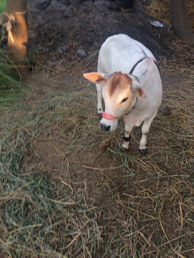

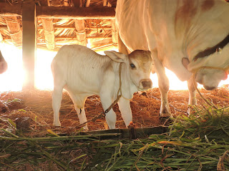

Posted by Dr. Ashok Singh at 10:14 AM

